Trina Shores ([katrina.shores@tamu.edu](mailto:katrina.shores@tamu.edu)) - Graduate Certificate in Stats (distance) - group leader

Steven Macapagal ([sf.macapagal@gmail.com](mailto:sf.macapagal@gmail.com)) - MS Stat (distance) - editor/analysis

Journey Martinez ([journeymartinez89@gmail.com](mailto:journeymartinez89@gmail.com)) - MS Stat (distance) - analysis/computation

Yuan Yao ([teasage@gmail.com](mailto:teasage@gmail.com)) - MS Biology (distance) - editor/analysis

Heather Nagy ([hnagy@tamu.edu](mailto:hnagy@tamu.edu)) - MS Stat (distance) - analysis

Kenneth Porter ([kporte@tamu.edu](mailto:kporte@tamu.edu)) - MS Stat (distance) - editor

**Background:**

The CDC estimates that each year roughly 1 in 6 Americans (or 48 million people) gets sick, 128,000 are hospitalized, and 3,000 die of foodborne diseases.Our dataset provides data on foodborne disease outbreaks reported to CDC from 1998-2015. Data fields include year, state, location where the food was prepared, reported food vehicle and contaminated ingredient, etiology, status, total illnesses, hospitalizations, and fatalities.

**Research Goals:**

Our goal with this project is primarily to describe the trends and variability in our illnesses data, to see if foodborne illnesses are seasonal, and if possible, to find relationships in our data to hospitalizations, fatalities, or external causes of illness.

**Preliminary Graphs & Analysis:**

Illnesses: Hospitalizations:

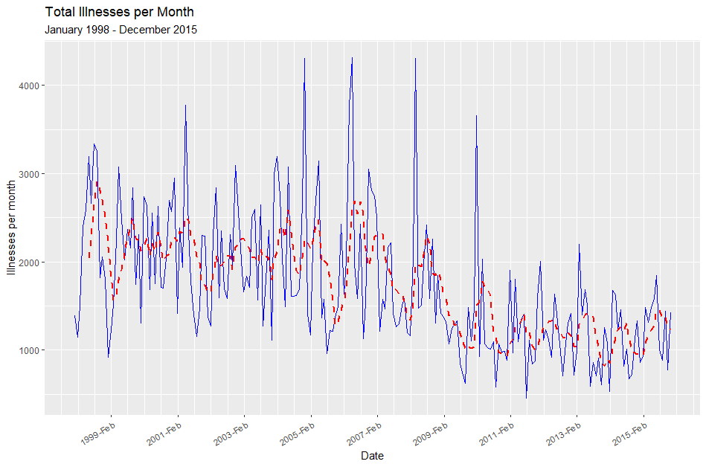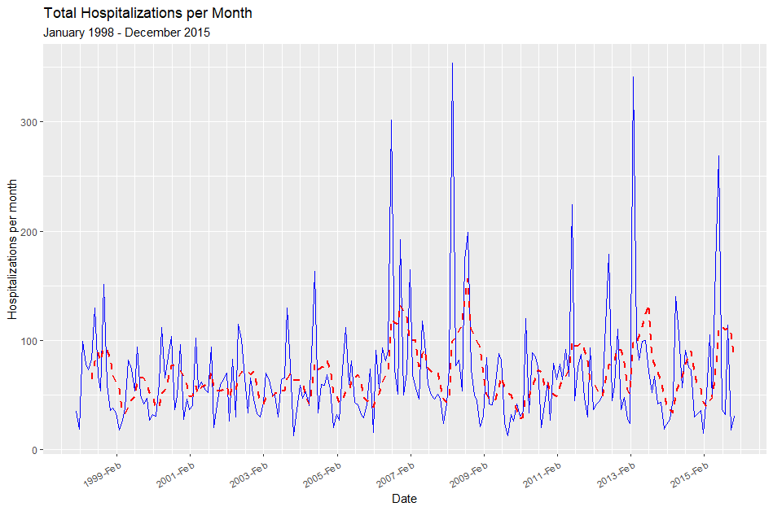

Fatalities: Seasonality:

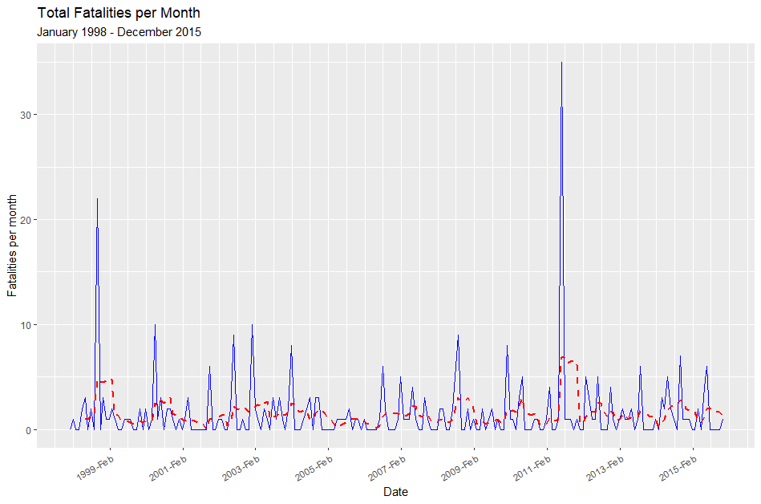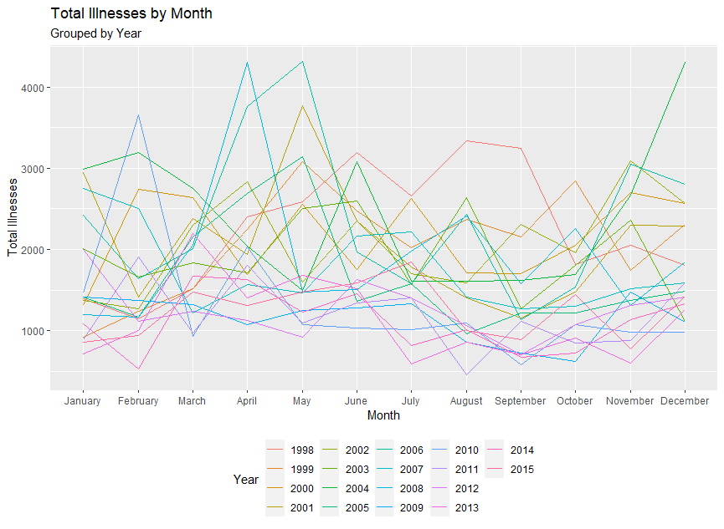

Illnesses: There appears to be a cyclic, downward trend in total number of illnesses per month, and a decrease in variability over time, particularly when comparing illnesses before and after 2008.

Hospitalizations: There seems to be an increase in variability of hospitalizations after 2006.

Fatalities: The number of fatalities per month appears to be relatively constant.

Seasonality: There is no visually clear seasonal pattern but the highest illness counts appear to be between February-May while the lowest are between July-November.